What is
Independent
Living?
Independent Living is a philosophy, a way of looking at disability
and society, and a worldwide movement of
people with disabilities working for
self-determination, self-respect, and
equal opportunities.

(disabled-world.com)
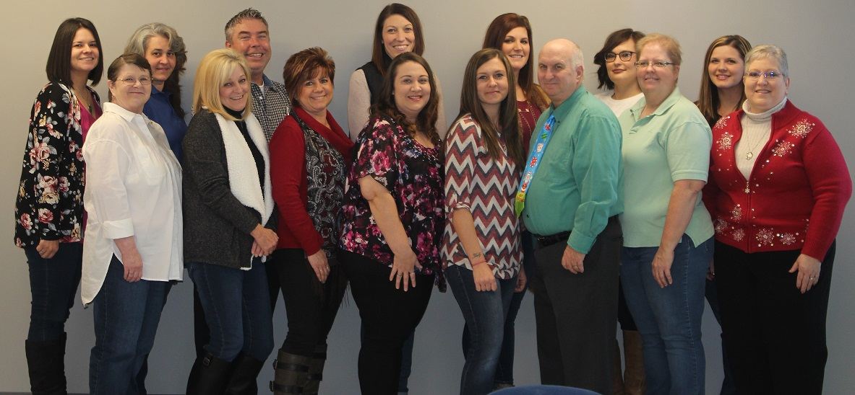
Heartland Independent Living Center
Heartland Independent Living Center (HILC) is a non-profit, non-residential organization that serves individuals with disabilities living in Franklin, Gasconade and Maries counties, as well as residents in several surrounding counties in east central Missouri.
Our programs and services assist people to become, or maintain, independence in their own homes through the assistance of a large number of programs and services offered without cost to the consumer. Those programs include, but are not limited to, Consumer Directed Services (CDS), In-Home Care services (IHC), adaptive equipment, assistive technology, dental services, the Care Closet, Disability Awareness Education, and the core services of Advocacy, Information & Referral, Independent Living Skills Training, Peer Support and Transition.
HILC is one of 22 Centers for Independent Living in the state of Missouri. HILC’s mission is to create "Accessibility for All." We seek to empower people with disabilities by helping them to live independently with dignity and security.

Heartland Staff- December 2017

PROGRAMS
IMPACT REPORT

January 2018

& Services

Core Services of Independent Living
- Advocacy - Specialists assist and advocate for individuals in acquiring needed services and benefits. In addition, Heartland advocates on behalf of people with disabilities by participating in the legislative process.
- Peer Support - Heartland believes many barriers can be broken and motivation obtained by mentoring among those with disabilities to encourage success and positive attitudes toward difficult issues and offering individuals the opportunity to meet people living with similar challenges.
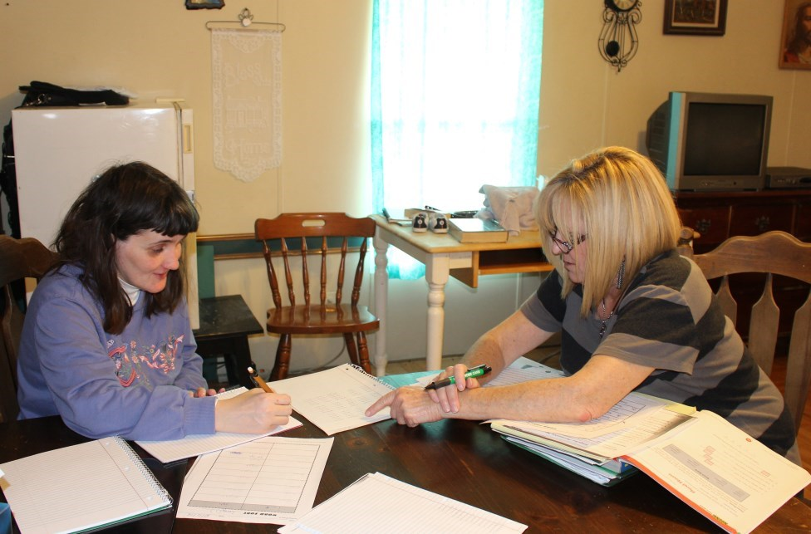
- Skills Training - Heartland offers training to individuals to improve skills needed to live independently, such as cooking, budgeting, and reading.
- Information & Referral - Heartland maintains a library of resources to assist consumers in finding appropriate resources, supports, and information.
- Transition- The long-anticipated fifth core service of independent living became reality when the President signed the Workforce Innovation and Opportunity Act (WIOA) in July 2014. The WIOA addresses transition in three areas: for individuals wishing to leave the nursing home or other institutional type setting, individuals in danger of being placed in such a facility, and transition for youth into post-secondary education or the labor force. Heartland offers counseling and assistance to nursing home residents seeking to leave institutional living. Staff Specialists facilitate the process of moving and obtaining necessary services.
Fiscal Year 2017 Fast Facts
- Total consumers served—780
- In-Home Care- 146
- Consumer Directed Services-228
- Care Closet—313
- TAP Telephones & internet provided— 31
- Assistive Equipment provided—149
- Dental Assistance—58
- Consumers receiving financial assistance—totaling $1,098
- Missouri Property Tax rebate program (MOPTC) processing assistance—$20,926 in total rebates
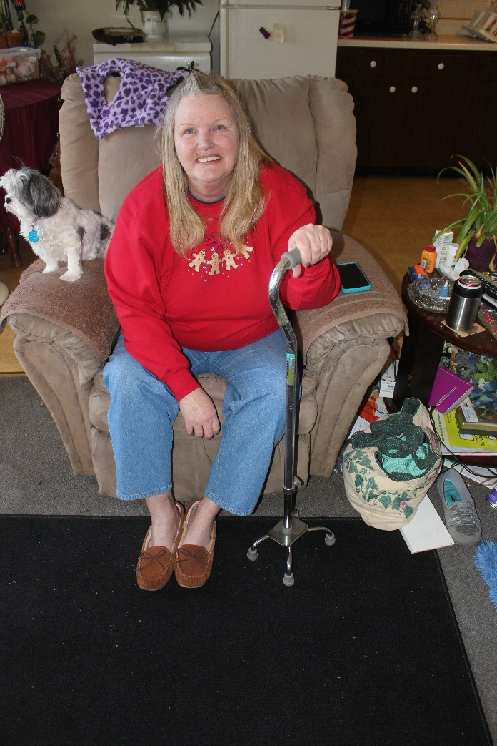

-

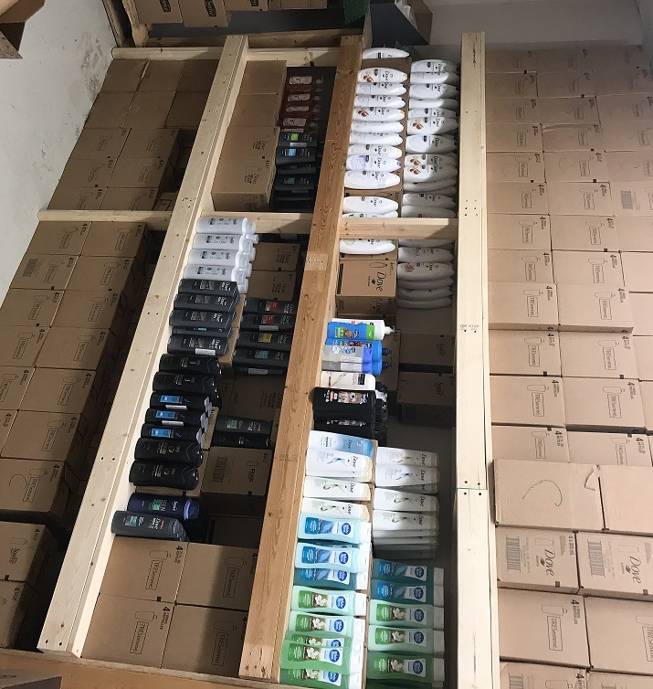
TAP Phones
Heartland is a certified demonstration organization for telephones specially designed for those with visual, hearing and mobility impairments. Staff specialists assist the individual in choosing a phone tailored to their needs and travel to the home to install it.

In-Home Care
Clients of In-Home Care receive assistance with activities of daily living from Heartland-employed aides. Need assessment, case management, and personal care are delivered by the In-Home Care Coordinator and Registered Nurses. Missouri Department of Health and Senior Services works with you to develop a Plan of Care that meets the personal needs you and your family express. Heartland ILC works with you and your family to manage that Plan of Care, ensuring that it meets your continued needs throughout the year. Staffing is guaranteed and services are provided as approved, including holidays and weekends.

Consumer Directed Services (CDS)
This program allows the redirection of Medicaid dollars for in-home care by consumer-employed personal care attendant, eliminating the necessity of placement in residential facilities due to lack of options. Heartland CDS Specialists assess consumer needs; furnish program support and case management; and guide the consumer, safeguarding that all program rules and regulations are followed.

-

Consumer Directed Services
)
CDS
(

This program allows the redirection of
Medicaid dollars for in
-
home care by a
consumer
-
employed personal care at-
tendant, eliminating the necessity of
placement in residential facilities due to
lack of options. Heartland CDS Specialists
assess consumer needs; furnish program
support and case management; and guide
the consumer, safeguarding that all pro-
gram rules and regulations are followed.

vices are provided as approved, including
holidays and weekends.

Care Closet
Heartland’s Care Closet was developed to temporarily ease the burden of obtaining household necessities, rather than having the population we serve compromise their independence and health. The Care Closet contains products such as deodorant, soap, shampoo, conditioner, laundry detergent, toilet paper, and all-purpose cleanser. Consumers are allowed to choose from a limited number of items at defined intervals. A person does not have to have a disability to be eligible for the Care Closet. Individuals must be age 62 and older and low income individuals/ family that meet HILC’s financial guidelines.
Dental
Dental services offered through Heartland is intended to offer relief for those suffering some form of dental discomfort but lacking the means to address it. Qualifying participants lack dental coverage, and have an income at or below 185% of the federal poverty level. Heartland arranges for services and payment through local dentists (easily accessible for the client).
Adaptive Equipment
Heartland loans and donates hundreds of assistive devices each year to disabled members of our service area to increase their level of independence and improve their quality of life. Individuals receiving donated and loaned items lack the resources to easily attain the items for themselves. Adaptive equipment is available to individuals according to medical necessity. Heartland accepts some donated equipment, which we recycle back into the community to those in need.

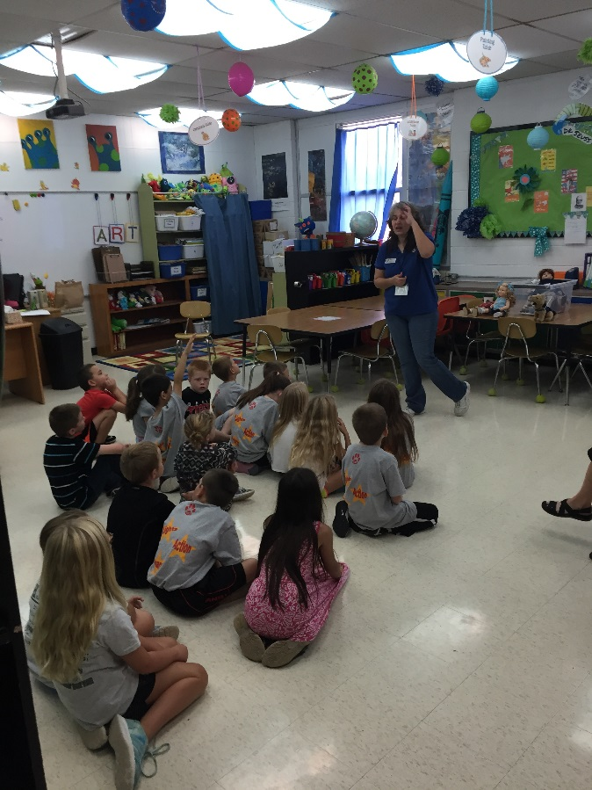
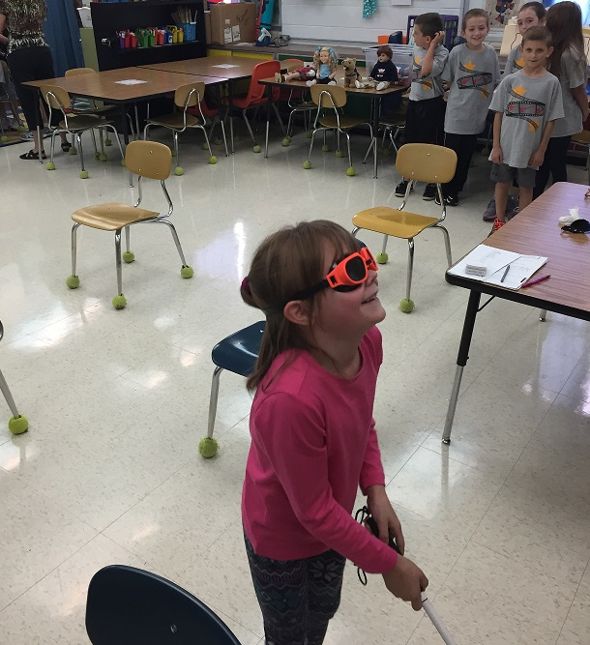
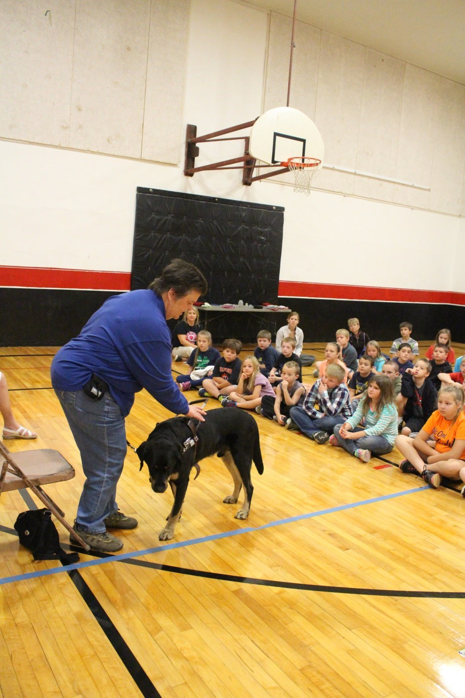
Disability Awareness Program
Heartland offers Disability Awareness Education to interested schools. Participants receive lessons in disability etiquette, including person first language and the dos and don’ts of interactions with service animals. Discussion sessions with individuals with a variety of disabilities provide the chance to ask questions. Furthermore, activities allow participants the opportunity to briefly experience what it may be like to have different disabilities, including: “blind” obstacle course, limited mobility, and dyslexia. The program was presented to approximately 1,000 school children per academic year.

In addition the program has been modified to benefit emergency responders to prepare them for addressing the needs of individuals with disabilities in emergency situations.

Service
COMMUNITY

FUNDING
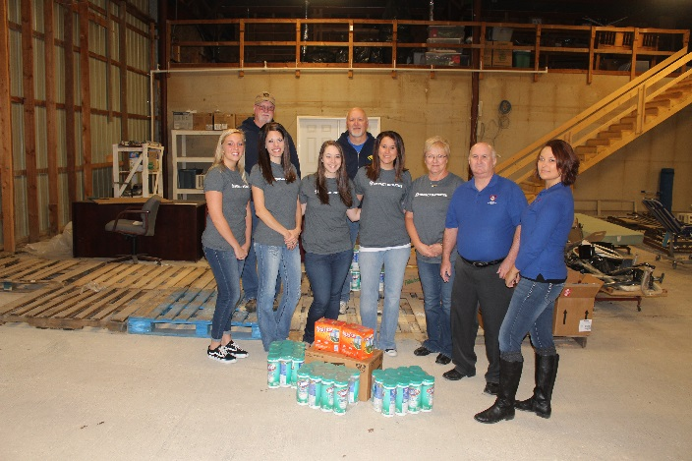

Approximately 95% of Heartland’s funding derives from earned revenue through service contracts. The majority of this income stems from Medicaid receipts through the Consumer Directed Services program and In-Home Care. Lesser portions are the result of service reimbursements from Veteran’s benefits for In-Home Care.
The remaining five percent of organizational income comes from contributed support. As a Center for Independent Living, Heartland receives an Independent Living grant and funds through Missouri Assistive Technology from the State of Missouri. Additionally, Heartland staff members and volunteers coordinate fundraisers throughout the primary service area. In recent years, contributions have been received from foundations such as the Owensville Garden Club, Missouri Dental Association Foundation, and First State Community Bank.
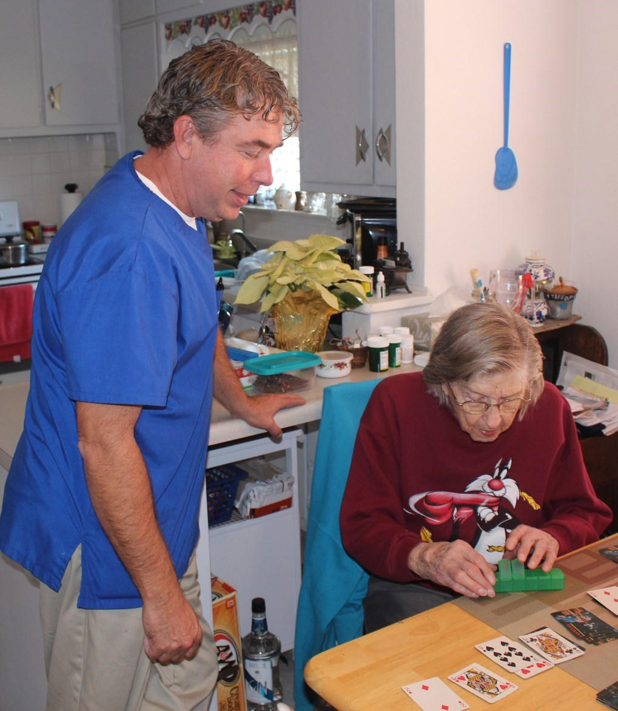
Population

SERVICE AREA

◻

24
% of all Missourians have some type of disability
(
Centers for Disease Control)

◻

Primary Service Area (Franklin, Gasconade, and Maries
Counties) Total Population: 125,794 (American Fact-
Finder)

◻

Poverty Rates (Missouri Association for Community
Ac-
Action):



Franklin 11.4%



Gasconade 12.1%



Maries 15.4%

◻

Demographics Snapshot (Based on our most recently
completed calendar year)



59
% of our consumers are age 60 and over



69
% of our consumers are female



74
% of our consumers have multiple disabilities

Heartland Independent Living Center
HILC In
-
Home Care 573.437.5111
∙

866.231.6652

hilcinhomecare@heartlandilc.org

www.heartlandilc.org

Because home is where the heart is.

1010 Hwy 28 West ∙ Owensville, MO 65066

573.437.5100 ∙ 866.322.3224 ∙ Fax 573.437.5117
hilc@heartlandilc.org

